*Don’t forget to hyperlink the events with your corresponding Shop URL!
Whether you've already booked your flights or are still toying with the idea of heading to Japan for the 2020 Summer Olympics, we’re here to tell you everything you need about the special event and how to make the most of this once in a lifetime experience.

First things first, the 2020 Summer Olympics will run from July 24 - August 9, and after a two-week break, the Paralympics will take place from August 25 - September 6. Over 300 events across 33 sports will be held in 9 venues across Tokyo; with most events happening in two main areas of Tokyo: The Heritage Zone and the Tokyo Bay Zone.

The Heritage Zone will hold events in upgraded buildings that were used in the 1964 Olympics, while the newly developed Tokyo Bay Zone will be used as a "model for innovative urban development." Soccer will be held outside of Tokyo at the Sapporo Dome, located on the northern island of Hokkaido, and Baseball will also be held outside Tokyo at the Fukushima Zuma Baseball Stadium in Fukushima.

What’s new this year?

There are 5 new sports this year:
- Skateboarding
- Sports Climbing
- Surfing
- Baseball and Softball
- Karate
You can also expect to see more events held for canoeing, kayaking, boxing, and fencing in order to create more gender equality in the Olympics.

How do I purchase tickets?
As with all of your other travel arrangements, we are here to take the stress and guesswork out of purchasing tickets to the Olympics! Through a trusted travel industry supplier, we are proud to offer individual tickets to all of the events, and/or hotel accommodations conveniently located across Tokyo. We that this a la carte option gives you the flexibility and confidence to curate the perfect Olympics experience.
From the Opening Ceremony to Closing Ceremony, our guide provides you with an easy to navigate list of all 300+ events and their corresponding purchasing links. Simply find your event in the Table of Contents, click the event of your choice, click the link and browse dates!

Where should I stay?

We are thrilled to offer hotels for the Tokyo Summer Olympics! All of our options are conveniently located around the stadiums, but you may find that one hotel is more convenient than the others based on which events you plan to attend.

Olympics Stadium Map: https://tokyo2020.org/en/games/venue/olympic/

Take a look at the map, hotel locations and rates below to decide which hotel is best for you.

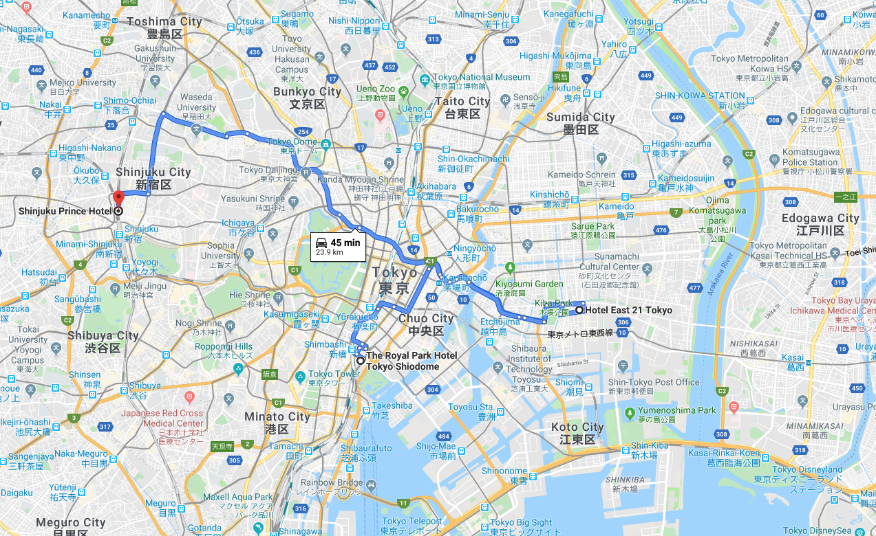

Hotel East 21 Tokyo
2 twin beds
6-night accommodation
Cost $5,250 USD
*prices subject to change
Check-in dates: 7/23, 7/29, 8/4,

Royal Park Shiodome
Economy Double
6-night accommodation
Cost: $6,090 USD
*prices subject to change
Check-in dates: 7/23, 7/29, 8/4

Shinjuku Prince Hotel
Twin Beds
6-night accommodation
Cost: $5,130
*prices subject to change
Check-in dates: 7/23, 7/29, 8/4

How can I get to the events around Tokyo?

The best way to get around Tokyo and to the events is on the train. Can't decipher the timetable? No problem! Head to http://www.hyperdia.com/ to map out your journey by entering your originating and destination stations. Make sure to pay close attention to which station you need to get off at so that you do not accidentally pass it by on an express train.

What should I pack?

Packing cubes
If you haven’t already invested in a pack of these lifesavers—now’s the time! Not only do they help you get all of your essentials into one bag, but they also help you stayed organized while you are abroad. Most 5-piece sets include one for shirts, one for bottoms, one for accessories, one for dirty clothes, and one for all of your Olympics souvenirs! Keeping everything organized in your suitcase and hotel room will help you make the most of your time in the morning so you can maximize your Olympics experience!

Sun Hats & Sunscreen
Tokyo is typically very sunny and hot during the summer months of July and August, which means you will want to pack ample sun protection. Whether you reapply sunscreen religiously, or prefer the shade of a hat or umbrella, you have plenty of options for keeping sunburns at bay. Personally, I love lightweight and breathable hats that I can easily toss in my suitcase or fold up into my day bag. Stay extra cool with portable rechargeable fans that can be plugged into your phone or carried around your neck.

Secure/anti-theft Travel Handbags
Amidst the celebrations leading up any Olympics events are safety concerns. While the pros take care of terrorist-related security breaches, you’re on your own when it comes to navigating the crowds on the streets. With big crowds of distracted people, you should always do your best to plan for the worst by packing your day bag as securely as possible. Lucky for you, clever bags like the Travelon Anti-Theft Bag have compartments with RFID blocking cards, passports slots, slash-proof construction, and adjustable. Cut-proof straps to help stop pickpockets in their tracks so you can focus on enjoying your vacation!

You can take your security a step further with RFID Blocking Passport and Currency Wallet’s to ensure you have a hassle-free experience in Tokyo.

Light Cotton Clothing
Not only will cotton clothing keep you cool in Tokyo’s blistering summer, but long sleeve shirts will also give you protection from the sun and insects. Plus, if you left room in your luggage for souvenirs, you can easily wash and re-wear cotton clothing items!

